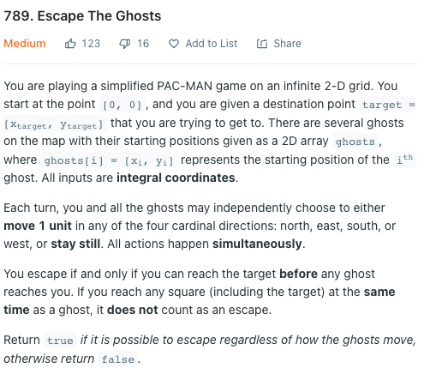

My Idea:

Finding who is the closet to target

If ghost is the closet -> False as they can always reach to target first and wait us  
If not -> True as they would always behind us and cannot block all the way we head to the target